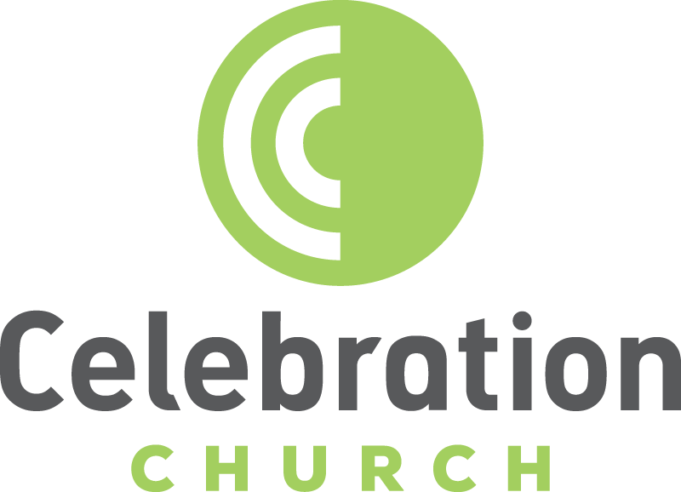

Celebration Church Adult Discipleship

Lesson 4 –
Spiritual Gifts Part 2

Pastor Frankie Mazzapica

What are Spiritual Gifts?

The Apostles Paul coins the term charism (charisma in Greek), meaning a gift freely bestowed. It is based on the word for “grace” (charis). A charism is what might be called a “gracelet,” a droplet of the vast ocean of God’s grace. A spiritual gift is an endowment or extraordinary power given by the Holy Spirit.

Common Spiritual Gifts

9 Charisma Gifts

For to one is given the word of wisdom through the Spirit, to another the word of knowledge through the same Spirit, 9 to another faith by the same Spirit, to another gifts of healings by the same Spirit, 10 to another the working of miracles, to another prophecy, to another discerning of spirits, to another different kinds of tongues, to another the interpretation of tongues. —1 Corinthians 12:8 – 10 (NKJV)
These gifts fall into three categories:
- Power Gifts: Gifts of healings, working of miracles, and faith.
- Speaking Gifts: Gifts of prophecy, different kinds of tongues, and word of knowledge.
- Discernment gifts: A word of wisdom, discernment of spirits, and interpretation of tongues.

7 Motivational Gifts

In his grace, God has given us different gifts for doing certain things well. So, if God has given you the ability to prophesy, speak out with as much faith as God has given you. 7 If your gift is serving others, serve them well. If you are a teacher, teach well. 8 If your gift is to encourage others, be encouraging. If it is giving, give generously. If God has given you leadership ability, take the responsibility seriously. And if you have a gift for showing kindness to others, do it gladly. —Romans 12:4 – 8 (NLT)

Access to the Gifts
You can grow in the gifts by becoming more aware of the voice of God and His will. In doing so, the operation of the gifts may become more common. However, you will always be dependent on the Holy Spirit. “If you have a gift of healing, for example, you cannot pull that gift out of your pocket and heal someone whenever you feel like it. Rather you are a musical instrument on which the Holy Spirit plays according to His times. The more yielded you are to the Him, the more freely He will play.”¹
Paul is referring to a special kind of speaking, not merely teaching. Someone who gives teaching is not usually considered to be speaking the very words of God, as is someone who speaks under the inspiration of the Spirit.

5 Office (Doma) Gifts
And He gave some to be apostles, some prophets, some evangelists, and some pastors and teachers, —Ephesians 4:11 (NKJV)
A true doma person is committed to training and equipping the church at large to grow in each one’s gifting so we can all bear fruit for God the Father.

I.] Healing During Church Service at the Altar
Types of Prayers:
(1) Declaration of Praise / Worship
I will say of the LORD, “He is my refuge and my fortress, my God, in whom I trust.”
—Psalm 91:2 (NIV)
(2) Intercession Prayers
Keep on asking, and you will receive what you ask for. Keep on seeking, and you will find. Keep on Knocking and the door will be opened to you.
—Matthew 7:7 (NLT)
(3) Petition Prayers
Large crowds followed Jesus as he came down the mountainside. Suddenly, a man with leprosy approached him and knelt before him. “Lord,” the man said, “if you are willing, you can heal me and make me clean.” Jesus reached out and touched him. “I am willing,” he said. “Be healed!” And instantly leprosy disappeared.
—Matthew 8:1 – 3 (NLT)
(4) Short Commanding Prayers
Then Jesus said to him, “Get up! Pick up your mat and walk.” At once the man was cured; he picked up his mat and walked. —John 5:8 – 9 (NIV)
Then Peter said, “Silver and gold I do not have, but what I do have I give you: In the name of Jesus Christ of Nazareth, rise and walk.” And he took him by the right hand and lifted him, and immediately his feet and ankle bones received strength. So he, leaping up, stood and walked and entered the temple with them—walking, leaping, and praising God. —Acts 3:6 – 8 (NKJV)

A Person with an Unclean Spirit
In the Gospels, I find 12 instances where Jesus is said to have “cast out a demon.” (Many of these instances are mentioned multiple times.) In nine of the twelve cases, the scripture simply says that Jesus cast out a demon or an unclean spirit. Only in three of the cases do we know exactly what Jesus said when he cast them out.
Capernaum Synagogue - 1 Sentence, 7 Words
But Jesus rebuked him, saying, “Be quiet, and come out of him!” And when the demon had thrown him in their midst, it came out of him and did not hurt him.
—Luke 4:35 (NKJV)
Two Men at Gergesenes (Gadarenes) - 2 Sentences, 12 Words
For he said unto him, Come out of the man, thou unclean spirit. And he asked him, What is thy name? And he answered, saying, My name is Legion: for we are many. —Mark 5:8 & 9 (NLT)
Father Brought His Demon-Possessed Boy - 1 Sentence, 16 Words
When Jesus saw that the people came running together, He rebuked the unclean spirit, saying to it, “Deaf and dumb spirit, I command you, come out of him and enter him no more!” —Mark 9:25 (NKJV)
Fascinating examples of God’s power over demons:
People at The Sea of Galilee
For he had healed many; insomuch that they pressed upon him for to touch him, as many as had plagues. And unclean spirits, when they saw him, fell before him, and cried, saying, Thou art the Son of God. And he straitly charged them that they should not make him known. —Mark 3:10 – 12 (KJV)
Man’s Son at Caesarea Philippi
And Jesus rebuked the devil, and he departed out of him: and the child was cured from that very hour. —Matthew 17:18 (KJV)

Words of Knowledge
When I open the floor for people to give a word of knowledge, I am looking for a specific physical sickness or illness.
I am not looking for a WOK about addictions, emotional healing, or prophetic words of encouragement.
We are using the gift to build the faith of the people.
- Addictions – your definition of an addict may not be theirs. Your belief in what is an unbiblical addiction may be debatable.
- Emotional Healing – everyone in the room has been emotionally hurt by someone.
- Prophetic Words – Prophetic words are usually so general, it’s too hard for the congregation to determine whether it’s from God or you. If you have specifics that are not debatable (name, birthdate, address, etc.), go for it! Your sentence should start with, “Is there someone here who ______?”
Follow the 5-Step Healing Model.
Get the phone number of those who have been healed.

II.] Gifts of Healings
- The Gift of Healing occurs when a Christian, acting on revelation, and by faith, brings the power of God to bear on another person’s physical, mental, or emotional need and healing takes place.
- These gifts of healing have nothing to do with IQ and are not gained by human experience or education, rather, it is supernaturally given by God.

“Gifts” – there are multiple gifts one may receive to heal.

Words can heal
Then Jesus said to him, “Get up! Pick up your mat and walk.” At once the man was cured; he picked up his mat and walked. —John 5:8 – 9 (NIV)
Then Peter said, “Silver and gold I do not have, but what I do have I give you: In the name of Jesus Christ of Nazareth, rise and walk.” And he took him by the right hand and lifted him, and immediately his feet and ankle bones received strength. So he, leaping up, stood and walked and entered the temple with them—walking, leaping, and praising God. —Acts 3:6 – 8 (NKJV)

Laying on of hands can heal
They *brought to Him one who was deaf and spoke with difficulty, and they *implored Him to lay His hand on him. —Mark 7:32 (NASB)

Garments of an anointed person can heal
Now God worked unusual miracles by the hands of Paul, so that even handkerchiefs or aprons were brought from his body to the sick, and the diseases left them and the evil spirits went out of them. —Acts 19:11- 12 (NKJV)
“It is strange that some wish to make a practice of that which the Bible describes as special.”¹ —Donald Gee

Just one’s presence can heal (Peter’s shadow, Acts 5:15 – 16)
“Healings” – physical, spiritual, mental, and emotional.
Gifts to Heal versus having the Power to Heal

Gift to Heal
“It is the one and only Spirit who distributes all these gifts. He alone decides which gift each person should have.” —1 Cor. 12:11 (NLT)
“But our bodies have many parts, and God has put each part just where he wants it.” —1 Cor. 12:18 (NLT)
“And God has appointed these in the church: first apostles, second prophets, third teachers, after that miracles, then gifts of healings, helps, administrations, varieties of tongues. Are all apostles? Are all prophets? Are all teachers? Are all workers of miracles? Do all have gifts of healings? Do all speak with tongues? Do all interpret? But earnestly desire the best gifts. And yet I show you a more excellent way.”
—1 Corinthians 12:29 – 31 (NLT).
Power to Heal
And these signs will follow those who believe: In My name, they will cast out demons; they will speak with new tongues; they will take up serpents; and if they drink anything deadly, it will by no means hurt them; they will lay hands on the sick, and they will recover.” —Mark 16:17, 18 (NKJV)
But if you remain in me and my words remain in you, you may ask for anything you want, and it will be granted! 8 When you produce much fruit, you are my true disciples. This brings great glory to my Father. —John 15:7 - 8 (NLT)
Parallel: Office of the Evangelist (Eph. 4:11) versus the Great Commission (Mt 28:19)

II.] Working of Miracles
The Greek word for “miracles” is dunamis from dunamai = to be able, to have power.
“The working of miracles … is a supernatural manifestation of the power of God that alters (that is, changes), suspends (that is, lays aside), or in some other way controls the laws of nature.” —Howard Carter

A Few Miracles Mentioned in the Old Testament
- Moses brought water out of a rock (Exodus 17:1-6).
- Israel crossed the Jordan on dry land (Joshua 3:l5-l7).
- Joshua made the sun stand still (Joshua 10:12-13).
- Elijah prayed down fire from heaven (1 Kings 18:37-38).
- Elisha made an axe-head float (2 Kings 6:1-7).

A Few Miracles in the Life of Jesus
- Jesus turned water into wine (John 2:1-11).
- Jesus calmed the stormy sea (Matthew 8:23-26).
- Jesus and Peter walked upon the water (Matthew 14:22-31).
- Jesus fed many people with a boy’s lunch (John 6:5-14).
- Jesus raised a man from the dead (John 11:1-44).

A Few Miracles in the Early Church
- Escape from prison (Acts 5:17-20).
- Dead raised (Acts 9:36-41).
- Escape from prison (Acts 12:5-17).
- An enemy of God blinded (Acts 13:6-11).
- No problem from snake bite (Acts 28:1-6).
There is one secret to all of these miracles being fulfilled. It is not the using of great men. It is not men with unusual powers of their own. It is the power of the Holy Spirit.
The “dynamite” of the Spirit is manifested to meet a great need on behalf of Christ’s body.
Often it was to move some obstacle and continue spreading the gospel.

Footnotes:
¹ Donald Gee, Spiritual Gifts in the Work of the Ministry Today, Springfield, Missouri: Gospel Publishing House, 963, 76.

